Automated Social Media Image & Branding Workflow
n8n | Claude | Gemini | Browserless | Google Sheets | Google Drive

Project Overview
Built an automated image production system for a law firm’s social media content.
The workflow takes an approved content idea and turns it into a finished branded social media graphic, including the image, text, description, hashtags, branding, and final file management.
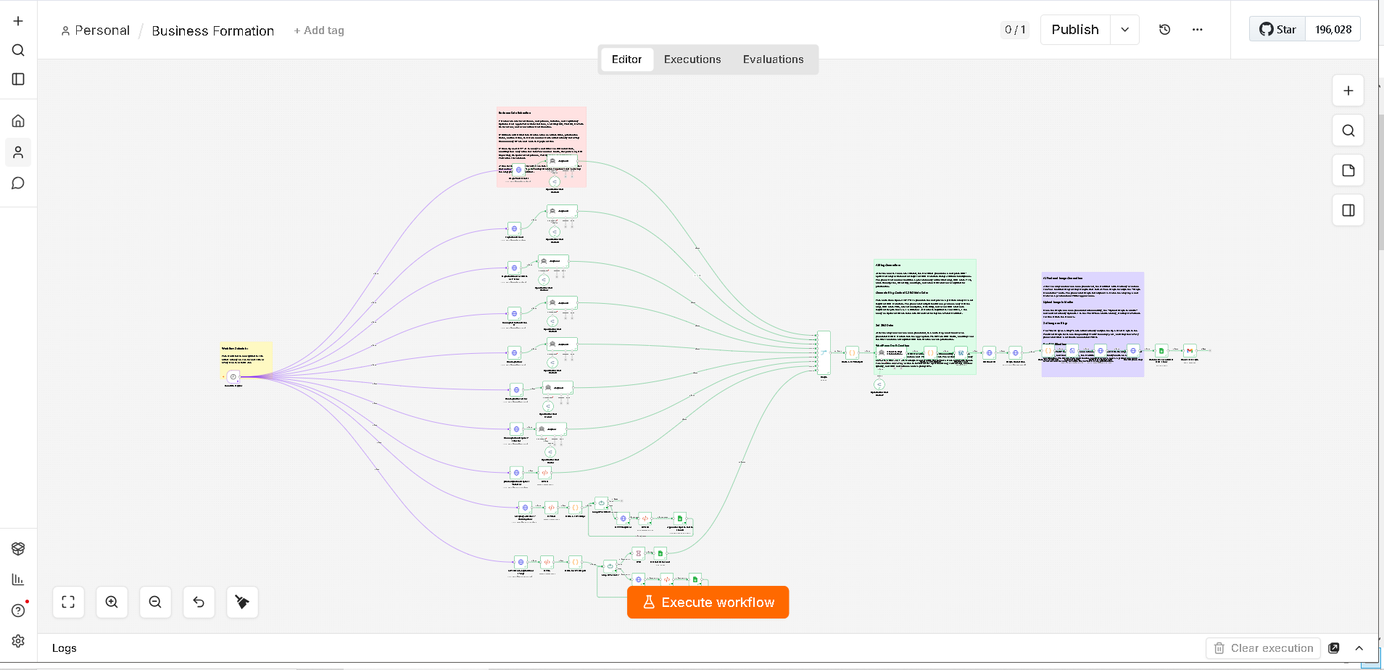
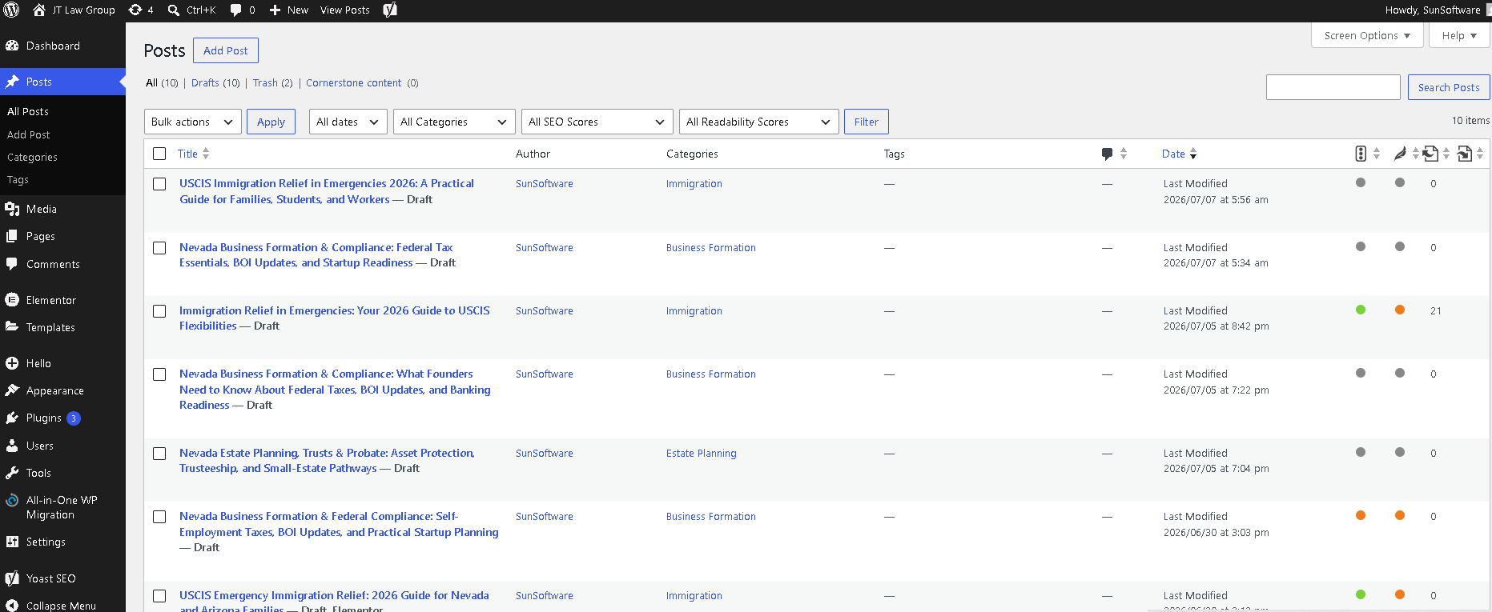

Workflow
The system:
• Retrieves pending content ideas from Google Sheets
• Generates the image prompt, headline, description, and hashtags
• Checks the generated content against predefined requirements
• Creates the image using Google Gemini
• Selects from 12 branded templates automatically
• Adds the firm’s logo, text, colors, and layout
• Renders the final design as a 1080 × 1080 PNG
• Uploads the finished graphic to Google Drive
• Removes temporary files after processing
• Updates Google Sheets with the final image, description, hashtags, and status

Branding & Templates
The workflow automatically rotates between 12 branded templates based on the content schedule.
Each template controls:
• Logo placement
• Image positioning
• Text overlays
• Brand styling
• Layout
This keeps the content visually consistent while avoiding repetitive designs.

Content Management
Google Sheets acts as the central content queue and tracking system.
Each completed post is updated with:
• Description
• Hashtags
• Final image URL
• Review status

Technology
• n8n
• Claude
• Google Gemini
• Browserless
• Google Sheets API
• Google Drive
• JavaScript
• REST APIs

Result
A complete automated design pipeline that turns a content idea into a branded, review ready social media graphic without requiring manual image creation or editing for every post.
The system also keeps content, assets, and approval status organized in one workflow.

